**Team Smiley - Application Layout Design - Paper prototype**

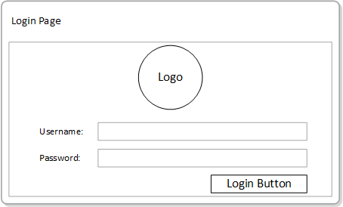

|  |
| --- |
| **Authentication** |
| As a student/faculty I want to login to CenEats so that I can view the available restaurants. |
| As a administrator I want to login so I can start monitoring CenEats. |
| As a Restaurant staff I want to login to CenEats so I can view orders that need to be prepared. |

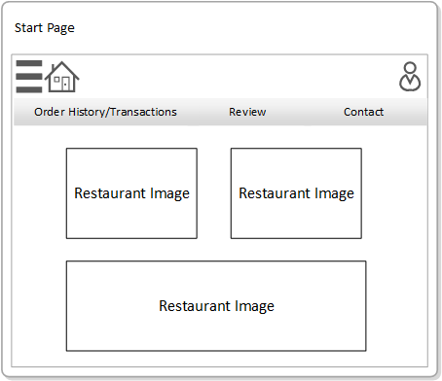

|  |
| --- |
| **Home page** |
| As a student/faculty I want to choose a restaurant so I can begin ordering food. |

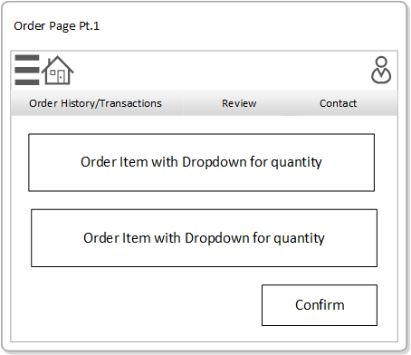

|  |
| --- |
| **Order - Create Order** |
| As a student/faculty I want to order an item from a restaurant so I can add it to my order |

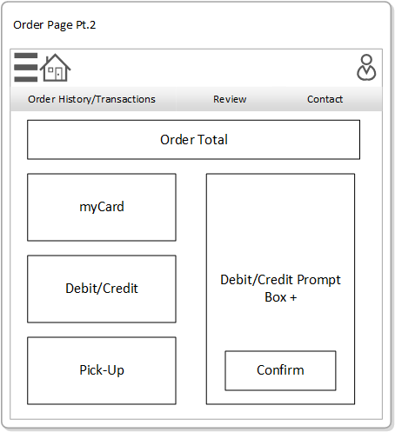

|  |
| --- |
| **Order - Payment** |
| As a student/faculty I want to purchase my order so I can confirm my order. |

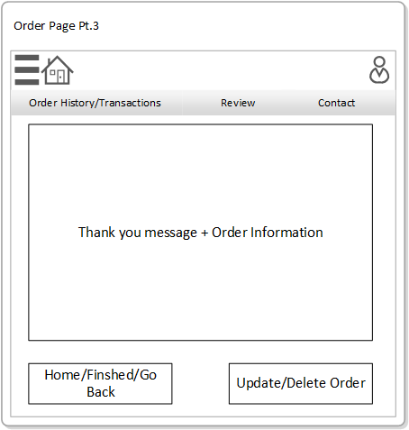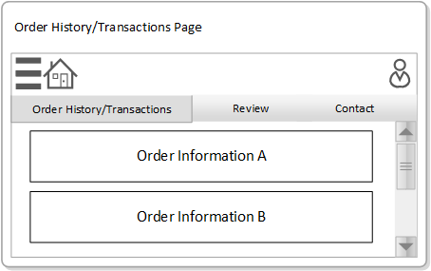

|  |
| --- |
| **Order - View Order** |
| As a student/faculty I want to view my order history so I can make sure my recent order was successfully submitted. |

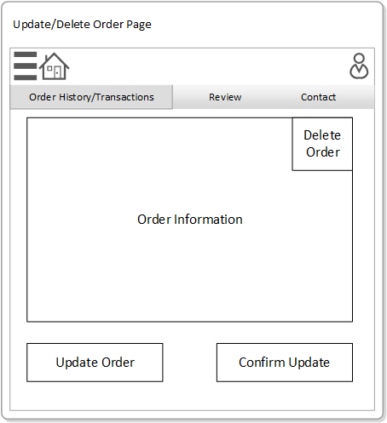

|  |
| --- |
| **Order - Update and Delete** |
| As a student/faculty I want to delete an order so I can cancel my order. |
| As a student/faculty I want to update an order so I can change the quantity of my order items. |

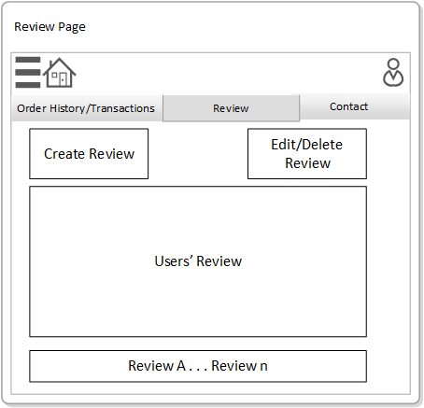

|  |
| --- |
| **Review - view review** |
| As a student/faculty I want to view other students/faculty reviews so I can benefit from other peoples experiences at restaurants. |

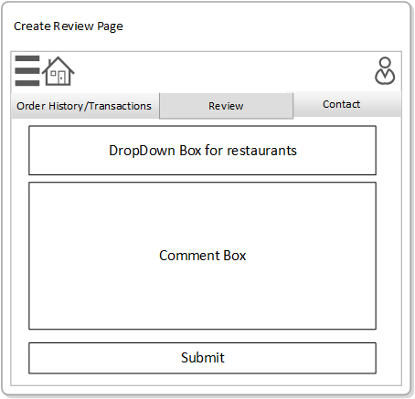

|  |
| --- |
| **Review - create review** |
| As a student/faculty I want to write a review so that I can state my opinion. |

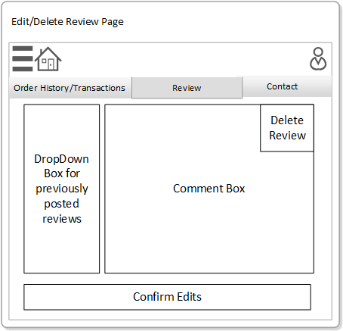

|  |
| --- |
| **Review - Edit/Delete** |
| As a student/faculty I want to update my review so I can fix any mistakes publicly viewed by other customers. |
| As a Customer Service Rep I want to delete a student/faculty review so inappropriate restaurant reviews can be removed. |

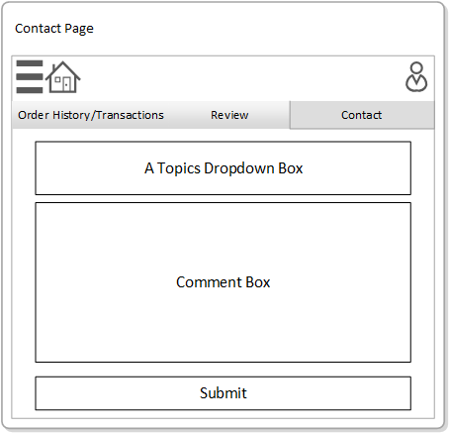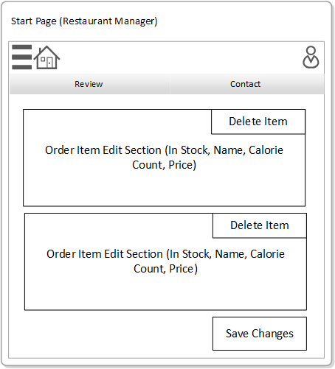

|  |
| --- |
| **Restaurant - Delete Order** |
| As a Restaurant Manager I want to update the stock status of an item to empty so customers can stop ordering that item. |

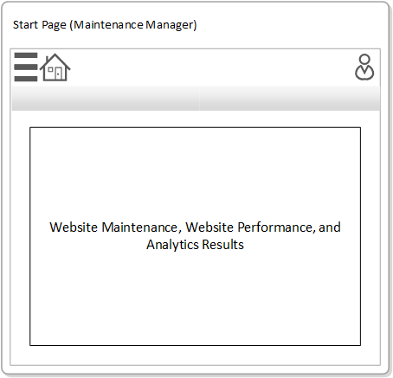

|  |
| --- |
| **Admin** |
| As a Website Maintenance Manager I want to monitor CenEats performance so I can measure their status. |